**Automated Seep Detection Tool Users Guide**

1. First, two folders need to be created. The location of the folders is up to the user.

2. Name both fo lders. For example:

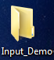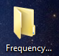

3. One folder (Input_Demo) should include PolSAR imagery with both HH and VV polarizations

4. The second folder (Frequency_Demo) should remain empty

C:\Users\kishii\Desktop\PowerPoint Images\arctoolbox.PNG5. Open ArcMap (ensure the spatial analyst extension is enabled. If not go to Customize->Extensions then check the box next to spatial analyst)

6. Once ArcMap is open, open the ArcToolbox window by clicking

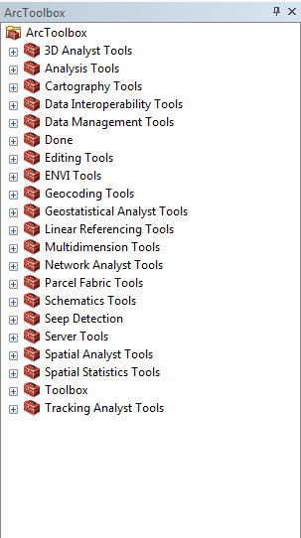7. In the ArcToolBox window, right click ArcToolbox->Add Toolbox

8. Browse to the appropriate folder to add the Seep Detection Tool.

9. Once the Seep Detection tool is found, select it and click add.

10. After adding the seep detection tool, double click the seep detection icon (shown below)

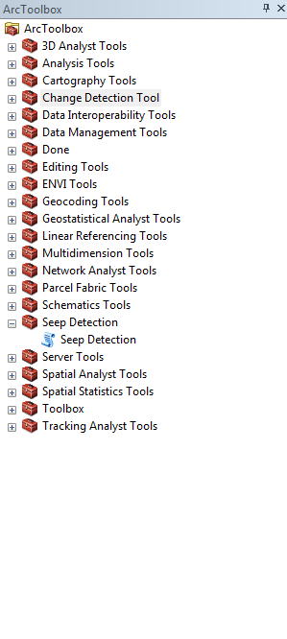

11. After double clicking, the following window should appear:

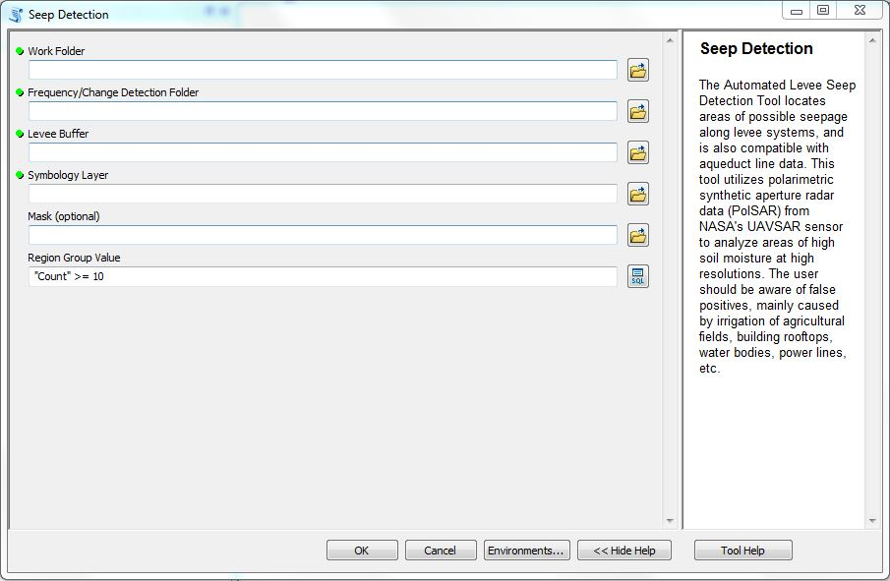

12. Click the folder icon (shown below)

13. Navigate to and select the folder with flight imagery , the symbology layer, mask raster, and the buffer shapefile. After selecting it click add (shown below)

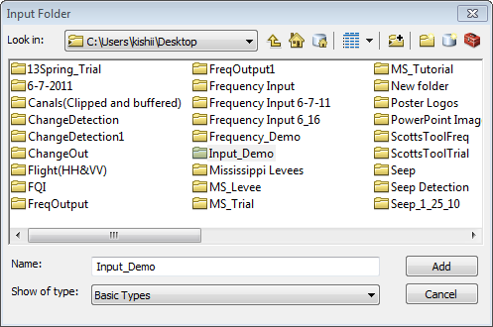

After clicking add, the folder will appear in the seep detection window (shown below)

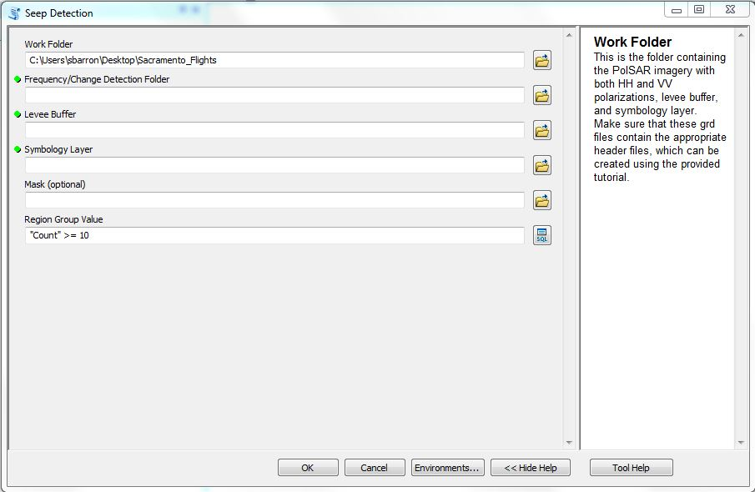

14. Repeat steps 12-13 for the remaining parameters.

The second parameter (Frequency /Change Detection Folder) is the second empty folder created in step 1. Levee Buffer is the buffer shapefile provided with the tool. Symbology layer is the symbology layer provided with the tool. Mask is an optional input to use a mask designed to remove false positives (i.e. vegetation, urban, roads etc.)

Region Group Value is the smallest group size of pixels. This is designed to help remove noise from the final products. The default is 10 (i.e. groups of 9 or less will be removed.) If you would like to change this parameter, simply erase “10” and replace it with a number of your choosing.

15. After all parameters are selected the seep detection interface window should look like below:

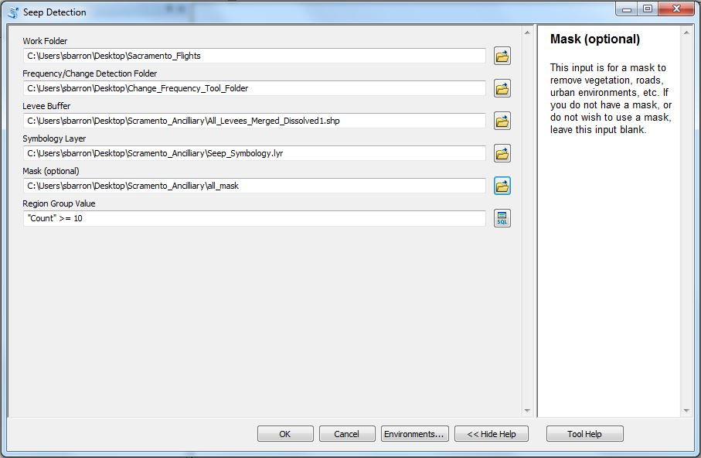

16. Click OK. The Seep Detection Tool will start running. The following window should appear:

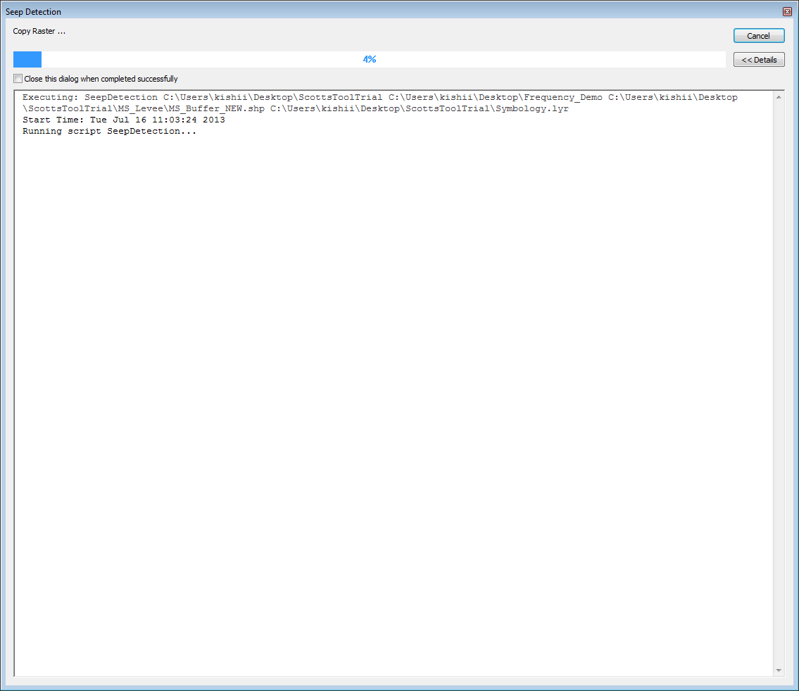

17. After the tool finishes processing, navigate to the first folder (Inpu t_Demo) and open the kmz file

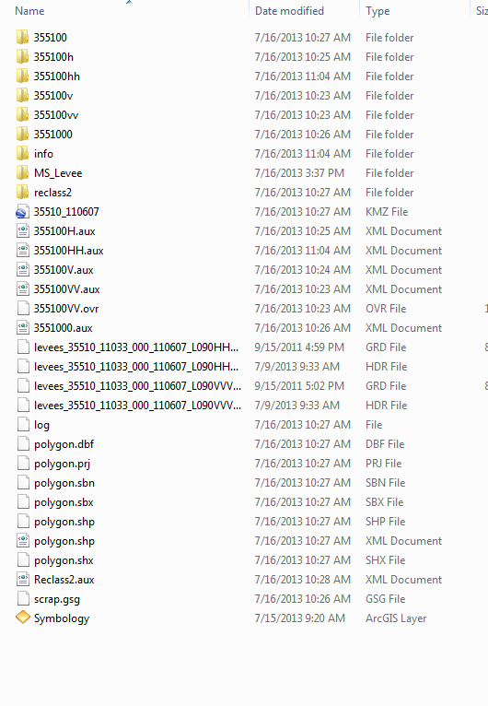

18. Once open in Google Earth, potential seepage areas can be explored. These areas should appear on you monitor in red

